- Today's Spring Statement is likely to prove a stopgap ahead of a more comprehensive overhaul of UK fiscal policy in this autumn's Budget.
- The Chancellor blamed global instability for the deterioration in the Office for Budget Responsibility's economic and fiscal forecasts. But the need to take remedial action was a consequence of leaving so little headroom in October's Budget, and the new plans leave a similarly slim margin for error in 2029-2030.
- We already thought the OBR's potential output forecasts were too optimistic, and today it upgraded them further after incorporating the impact of the government's planning reforms. After years of productivity growth disappointing, we think the risks are heavily skewed towards a worse outcome.
- The new plans assume the government will increase defence spending to 2.5% of GDP. But the NATO target will likely rise to 3% or more, forcing the government to choose between further tax rises, greater spending restraint, or changing its fiscal rules yet again.
Chancellor Rachel Reeves had promised that her government would only hold one fiscal event a year. In keeping with this promise, today's Spring Statement contained no new tax announcements. But unfavourable forecast revisions from the Office for Budget Responsibility forced Reeves to make a series of announcements on spending to remain compliant with her fiscal rules with a decent margin for error.
In the absence of policy changes, the OBR said the government would miss its borrowing rule by £4.1bn. This represented a £14bn increase in borrowing from October's Budget, mainly due to higher debt interest costs. But the OBR was convinced to incorporate the impact of the government's planning reforms, which it said would increase potential output growth and tax receipts. Swapping foreign aid for defence spending further helped the arithmetic, as we had flagged it would. Adding in measures to reduce tax avoidance and recently announced welfare reforms restored headroom to the same £9.9bn in October's Budget (Chart 1).
Chart 1: Unfavourable OBR forecast changes forced the Chancellor into remedial action
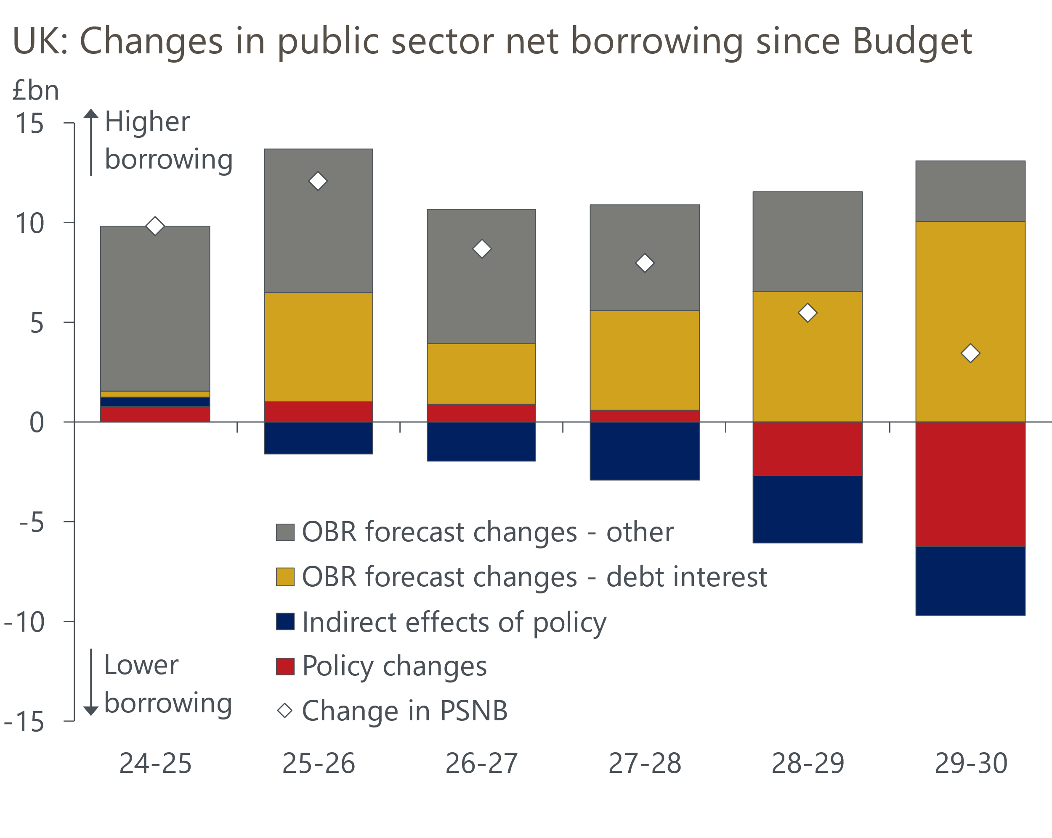
Source: Office for Budget Responsibility

The OBR's growth forecasts look very optimistic
We've long suggested the OBR is too optimistic about the outlook for potential growth and had flagged the possibility of a downgrade today. Instead, the OBR revised up its forecast after incorporating the impact of the government's planning reforms. The OBR's medium-term forecast for total factor productivity assumes a recovery towards historical norms, without considering how this would be achieved. To score a specific policy as boosting their initial potential output assumption looks inconsistent with this approach.
The OBR presented two alternative scenarios for productivity growth – one upside and one downside. But we think this does not accurately reflect the skew of the risks. Even before incorporating the planning reforms, the OBR's central forecast for potential output growth was well above the consensus. Adopting stronger assumptions makes the OBR's forecast even more of an outlier. We think the risks are skewed towards a worse outcome and there's a strong chance the forecast will need to be downgraded at a subsequent fiscal event. Furthermore, there's a major question about whether the fiscal watchdog should adopt such an out-of-consensus view for a key variable without having a strong rationale.

Putting the spending plans into context
All the cuts to current spending come from welfare reforms. Departmental spending is higher throughout the forecast horizon, and particularly in the period that will be covered by June's spending review (Chart 2). As the OBR pointed out, the plans do still mean that budgets for unprotected departments (i.e. those outside of health, education, and defence) will be cut in real terms in the outer years of the forecast horizon. But these cuts will come from a much higher starting level than envisaged in the plans before last year's election.
Chart 2: Departmental spending plans are much higher than those inherited from the last government
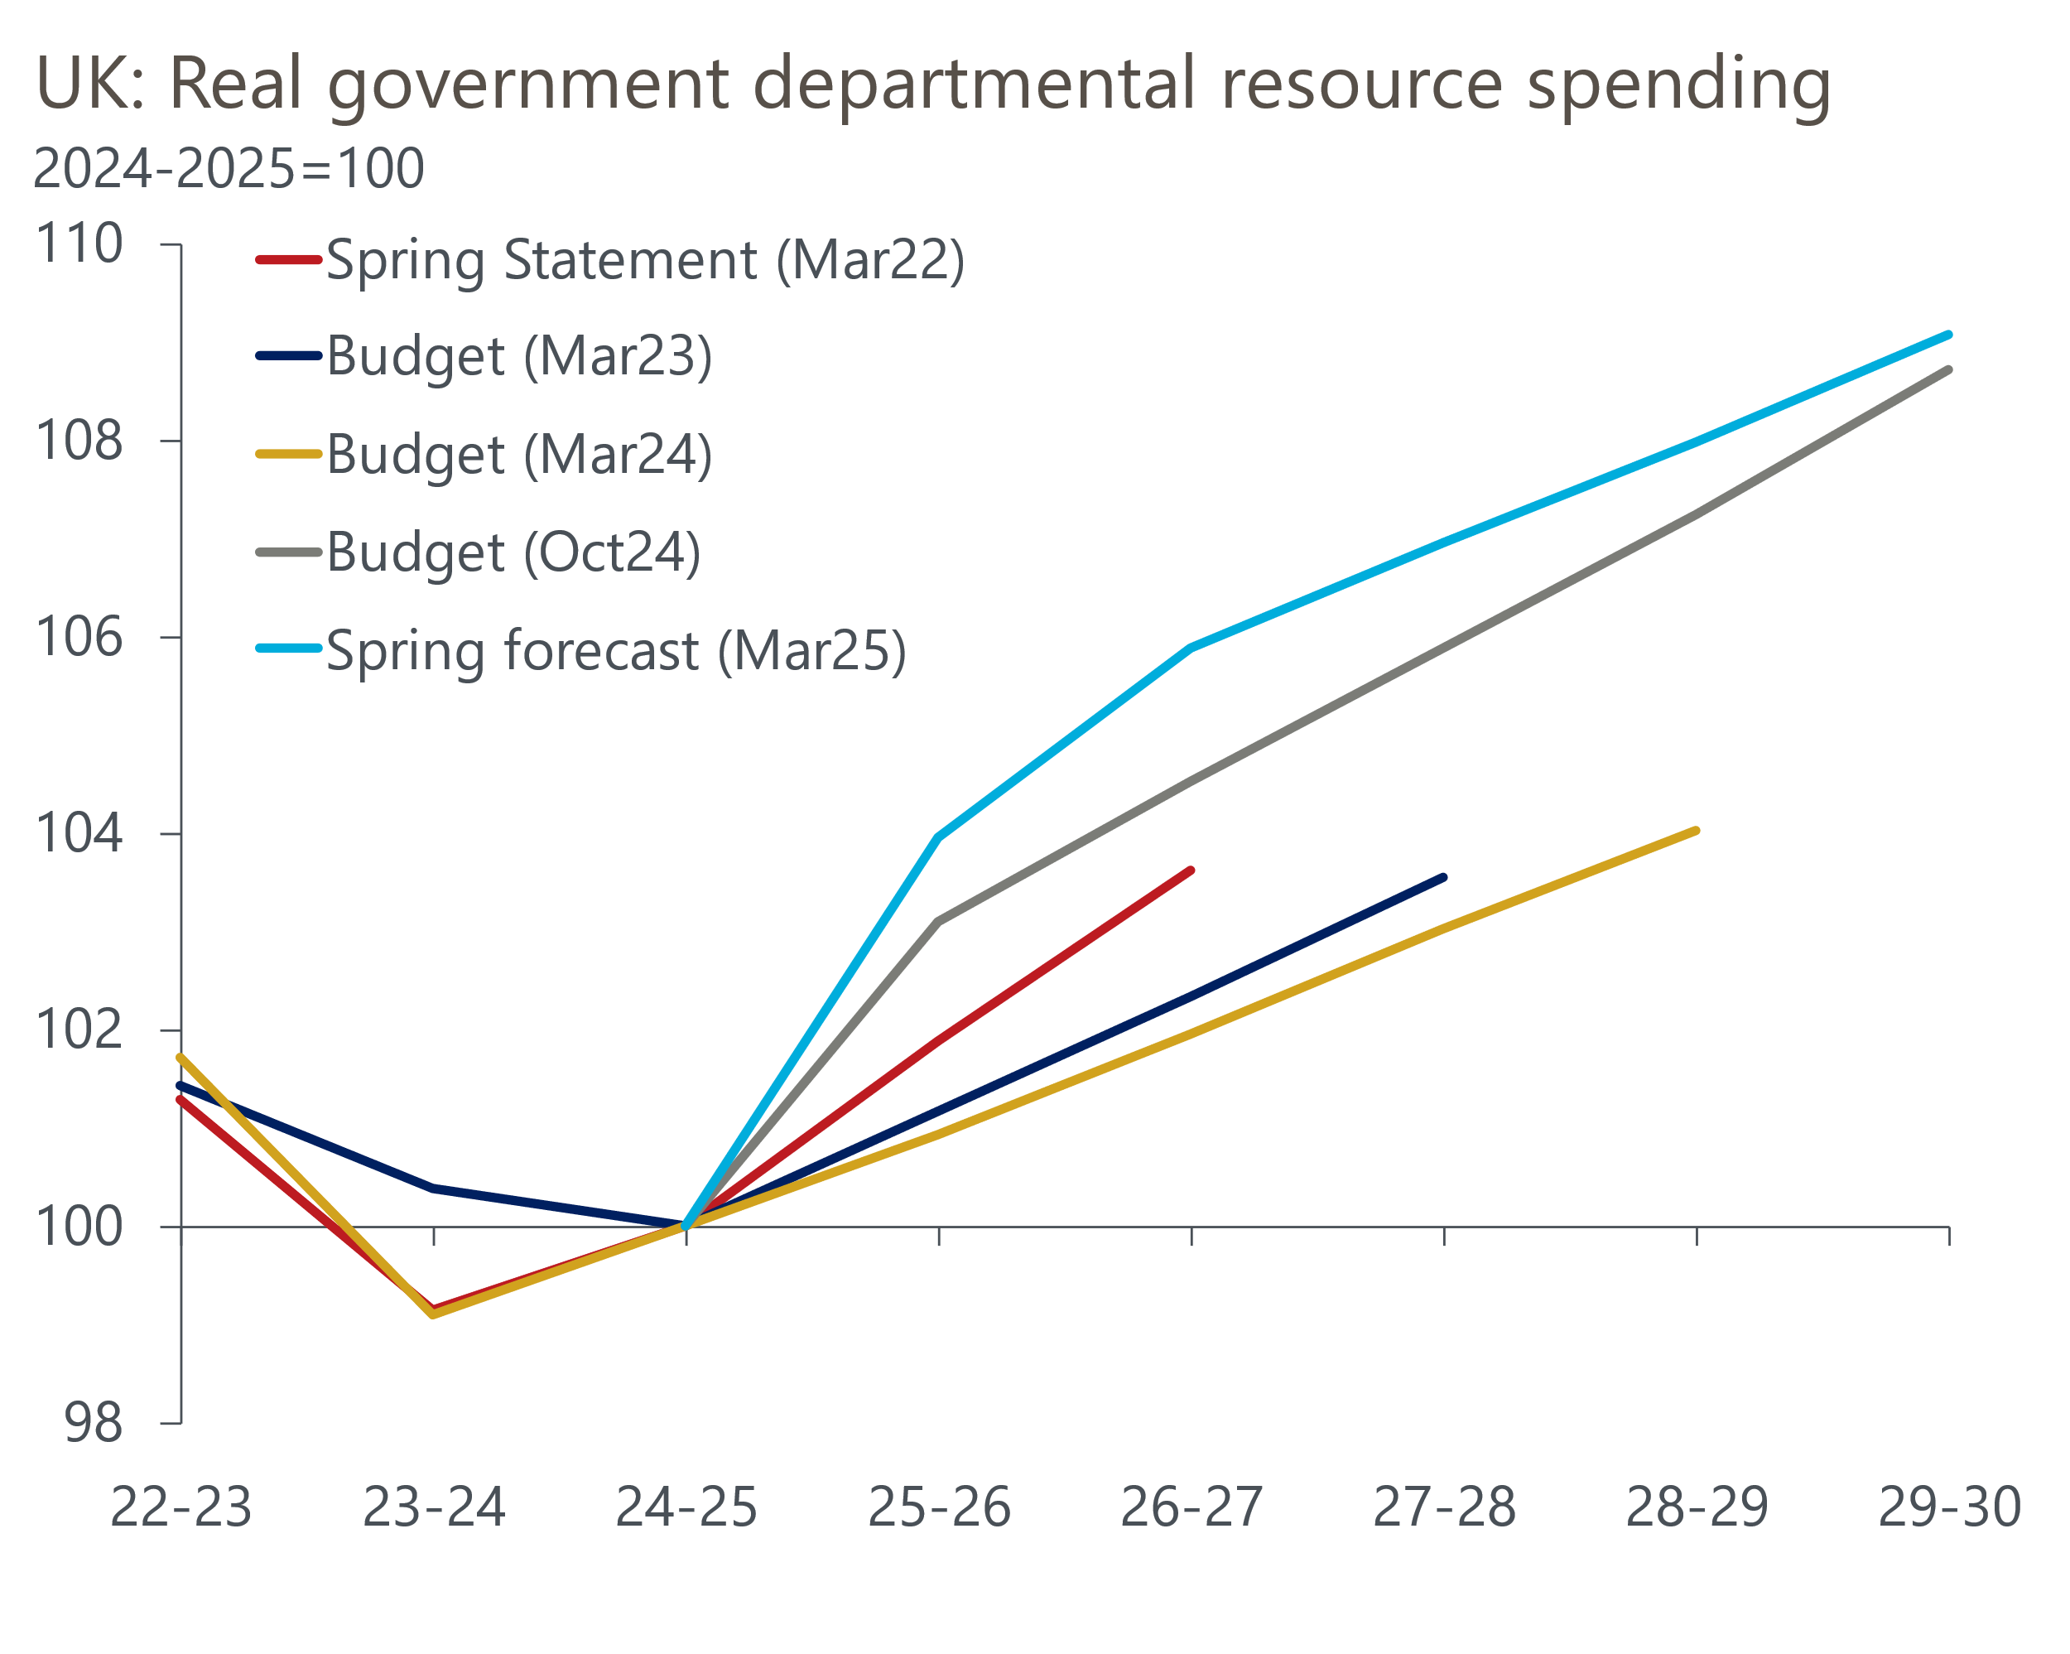
Source: Oxford Economics calculations using forecasts from OBR
The new plans assume the government will increase defence spending to 2.5% of GDP. But there's a good chance that the NATO target will rise to 3% of GDP or more in the summer. The OBR estimates meeting that higher target would involve increasing spending by £17.3bn in 2029-2030, almost double the headroom the Chancellor has left against her borrowing rule.

A more comprehensive rethink of fiscal policy will be needed
Overall, we view today's Spring Statement as a can-kicking exercise. The Chancellor has again opted to leave a very slim margin for error against her fiscal rules, which is very risky in an uncertain world. We view the risks to the OBR's economic forecast as being heavily skewed to the downside, implying higher borrowing. So, there's a high probability the official forecaster will be forced to downgrade its economic outlook significantly at a future fiscal event, causing a larger version of today's search for savings to make the sums add up. And with no provision to increase defence spending to the level that is likely to be required, it's clear that there will need to be a more comprehensive rethink of fiscal policy ahead of the Budget in the autumn.
Manifesto pledges not to increase tax will likely need to be revisited. The Chancellor may also look to squeeze spending further in the outer years of the forecast horizon, in the hope that the extra cuts won't ultimately be needed or can be postponed when the forecast horizon moves forwards. Another change of fiscal rules, possibly excluding defence spending, cannot be ruled out.

